Nested if Statement

# Largest Among Three Numbers :

<!DOCTYPE html>

<html lang="en">

<head>

    <meta charset="UTF-8">

    <meta name="viewport" content="width=device-width, initial-scale=1.0">

    <title>Find Largest Number</title>

    <style>

        body {

            font-family: 'Segoe UI', Tahoma, Geneva, Verdana, sans-serif;

            background-color: #f5f5f5;

            display: flex;

            justify-content: center;

            align-items: center;

            height: 100vh;

            margin: 0;

        }

        .container {

            background: #ffffff;

            border: 2px solid #1f00aa;

            border-radius: 12px;

            box-shadow: 0 4px 8px rgba(0, 0, 0, 0.2);

            padding: 20px;

            width: 350px;

            text-align: center;

        }

        input, button {

            padding: 12px;

            margin: 10px 0;

            border: 2px solid #1f00aa;

            border-radius: 6px;

            width: calc(100% - 24px);

            box-sizing: border-box;

        }

        button {

            background-color: #000095;

            border: 2px solid #1f00aa;

            color: #ffffff;

            border: none;

            cursor: pointer;

        }

        button:hover {

            border: 2px solid #150070;

        }

        .result {

            margin-top: 20px;

            font-weight: bold;

            color: #004d40;

            text-align: left;

        }

        .result p {

            margin: 5px 0;

        }

    </style>

</head>

<body>

    <div class="container">

        <h1>Find Largest Number</h1>

        <input type="number" id="num1" placeholder="Enter Number 1" required>

        <input type="number" id="num2" placeholder="Enter Number 2" required>

        <input type="number" id="num3" placeholder="Enter Number 3" required>

        <button onclick="findLargest()">Find Largest</button>

        <div class="result" id="result" style="display: none;">

            <p id="largestNumber"></p>

        </div>

    </div>

    <script>

        function findLargest() {

            // Fetch input values

            const num1 = parseFloat(document.getElementById('num1').value);

            const num2 = parseFloat(document.getElementById('num2').value);

            const num3 = parseFloat(document.getElementById('num3').value);

            // Initialize largest number

            let largest;

            // Determine the largest number using nested if

            if (num1 > num2) {

                if (num1 > num3) {

                    largest = num1;

                } else {

                    largest = num3;

                }

            } else {

                if (num2 > num3) {

                    largest = num2;

                } else {

                    largest = num3;

                }

            }

            // Display result

            document.getElementById('largestNumber').textContent = `The largest number is: ${largest}`;

            document.getElementById('result').style.display = 'block';

        }

    </script>

</body>

</html>

# OutPut :

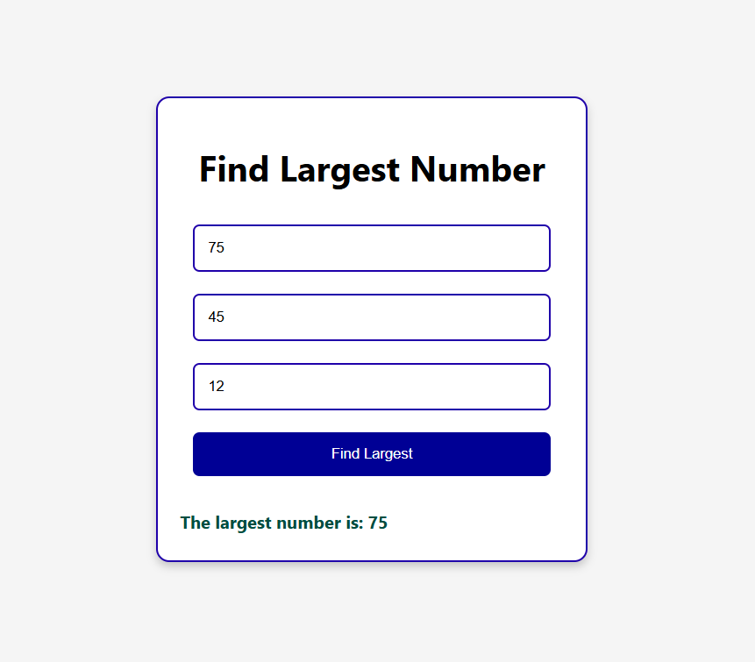

# Check Loan Eligibility :

<!DOCTYPE html>

<html lang="en">

<head>

  <meta charset="UTF-8">

  <meta name="viewport" content="width=device-width, initial-scale=1.0">

  <title>Loan Eligibility Checker</title>

  <style>

    body {

      font-family: Arial, sans-serif;

      background-color: #f4f4f9;

      margin: 0;

      padding: 20px;

      display: flex;

      justify-content: center;

      align-items: center;

      height: 100vh;

    }

    .container {

      background-color: white;

      padding: 20px;

      border-radius: 8px;

      box-shadow: 0 4px 6px rgba(0, 0, 0, 0.1);

      width: 300px;

      text-align: center;

    }

    .input-group {

      margin-bottom: 15px;

    }

    input[type="number"] {

      width: 100%;

      padding: 10px;

      margin-top: 5px;

      font-size: 14px;

      border: 1px solid #ccc;

      border-radius: 4px;

    }

    button {

      background-color: #4CAF50;

      color: white;

      padding: 10px;

      width: 100%;

      font-size: 16px;

      border: none;

      border-radius: 4px;

      cursor: pointer;

    }

    button:hover {

      background-color: #45a049;

    }

    .result {

      margin-top: 20px;

      font-size: 16px;

      font-weight: bold;

    }

    .result p {

      margin: 5px 0;

    }

    .approved {

      color: green;

    }

    .denied {

      color: red;

    }

  </style>

</head>

<body>

  <div class="container">

    <h2>Loan Eligibility Checker</h2>

    <div class="input-group">

      <label for="age">Enter your Age:</label>

      <input type="number" id="age" placeholder="Enter your age" required>

    </div>

    <div class="input-group">

      <label for="salary">Enter your Salary:</label>

      <input type="number" id="salary" placeholder="Enter your salary" required>

    </div>

    <button onclick="checkLoanEligibility()">Check Eligibility</button>

    <div class="result" id="result"></div>

  </div>

  <script>

    function checkLoanEligibility() {

      let age = parseInt(document.getElementById('age').value);

      let salary = parseInt(document.getElementById('salary').value);

      let resultDiv = document.getElementById('result');

      resultDiv.innerHTML = '';  // Clear previous result

      if (isNaN(age) || isNaN(salary)) {

        resultDiv.innerHTML = "<p class='denied'>Please enter valid numbers for age and salary.</p>";

        return;

      }

      if (age >= 21) {

        resultDiv.innerHTML = "<p class='approved'>You are eligible to apply for a loan.</p>";

        if (age < 30) {

          if (salary >= 30000) {

            resultDiv.innerHTML += "<p class='approved'>Loan approved: Your salary meets the requirement for applicants under 30.</p>";

          } else {

            resultDiv.innerHTML += "<p class='denied'>Loan denied: Salary should be at least $30,000 for applicants under 30.</p>";

          }

        } else {

          if (salary >= 25000) {

            resultDiv.innerHTML += "<p class='approved'>Loan approved: Your salary meets the requirement for applicants 30 and above.</p>";

          } else {

            resultDiv.innerHTML += "<p class='denied'>Loan denied: Salary should be at least $25,000 for applicants aged 30 and above.</p>";

          }

        }

      } else {

        resultDiv.innerHTML = "<p class='denied'>Loan denied: You must be at least 21 years old to apply for a loan.</p>";

      }

    }

  </script>

</body>

</html>

# OutPut :

